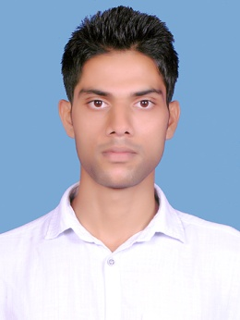
Muneer vengali

Vengali(house),vilayur west(post),

Pattambi(via),palakkad(dist),

Kerala, india-679 309

Email:muneervmh033@gmail.com
CAREER OBJECTIVE
To work as an aircraft maintenance engineer, to be worked with great team and great personalities.
PROFILE SUMMARY
- An enthusiastic and highly motivated character having bachelor of science in aircraft maintenance engineering.
- Experienced in marketing and management.
- Eager to be perfect in work and good in deals.
- Eager to learn new technologies, cultures as well as languages.
PERSONALITY TRAITS
- Highly interested in having good knowledge.
- Ability to work as individual as well as in group.
- Playing games and exercising keeps healthy and pleasant.
EDUCATIONAL QUALIFICATION
- Completed bachelor of science in aircraft maintenance engineering with 73%
- Passed paper1 (civil aviation requirements) with 77%
- Completed 10+2 under kerala state syllabus with 63%
- Completed sslc under kerala state syllabus with 65%
TECHNICAL QUALIFICATION
- Undergone training at hindusthan aeronautics limited, Bangalore on line and base maintenance of helicopter ALH-DHRUV powered with turbomeca-333-2b2.
- Associated in transit inspection, daily inspection, weekly inspection, component replacement, and snag rectification of ALH-DHRUV turbomeca-333 2b2.
- Relevant knowledge in submitting value added tax and income tax.
- Relevant knowledge in internet surfing.
EXTRA CURRICULAR ACTIVITIES
- Practice kalari and yoga.
- Reading books.
- Participated in youth festival at district level.
PERSONAL DETAILS
Languages known : Hindi, English, Kannada and Tamil
Date of birth : 23rd April 1989
Passport number : K3025922
Contact number : (0091) 90480-68886, 85890-88890
DECLARATION
I here by declare that all the above informations are correct and true in my knowledge.

(MUNEER VENGALI)

